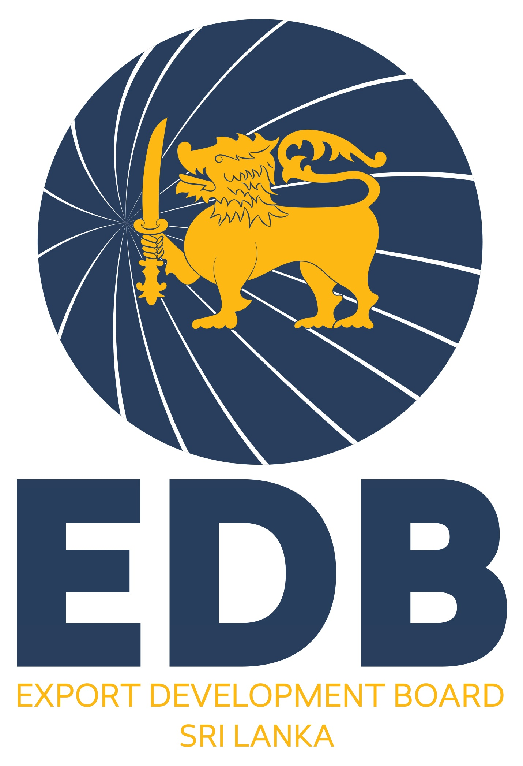
SRI LANKA EXPORT DEVELOPMENT BOARD
APPLICATION
GULFOOD 2026- FOOD & BEVERAGE EXHIBITION, DUBAI, UAE
FROM 26th – 30th JANUARY 2026

01 | Name of the Company ►
01 | Address ▼
01 | Office ► |  |  |  |  |  | Processing Plant ►
01 | Tele ► |  |  |  | Fax ► |  | Email ► |  | Website ►
02. | Name Designation & Contact No of the Contact Person related to GULFOOD ►
03 | Name & Designation of the participant/s in the above programme ►
04. | Year of establishment ►
05. | Type of Business ▼
05. |  Producer  Producer- Exporter  Agent  Trading House  Other (Specify)
06. | Legal Status ▼
06. |  Proprietorship  Public Quoted Company  Partnership   State Owned  Private Ltd Company  Other (Specify)
07. | Equity ► Local : % Foreign : % Partner country :
08. | Is your company a part of a group of companies?  Yes  No  If yes, state the name of the parent company ►
09. | Total number of employees ► Managerial: Skilled/ Semi/Unskilled:
10 | Total Investment (excluding land and buildings) as at 31 Dec. 2024 (Rs. Mn) ►
11 | Products Exporting /Capacity ▼
 | Main Products Exporting |  |  |  |  | Production Capacity/ Year (Mt) |  |  |  | Export Capacity/ year (Mt)
1
2
3
4
5
6
12 | Current major export markets and share (%) ▼
13 | Annual Turnover (LKR Mn)▼
 | Year |  | Local Turnover |  |  | Export Turnover |  |  |  | Total Turnover
2022
2023
2024
14 | Exports to Middle East & African Region (in last 3 years) in US$ Mn►  2022 2023 2024
15 | Quality Standards Obtained  (GAP, GMP, SLSI, HACCP, ISO, Organic, Fairtrade etc) ▼
16 | Products that you are planning to promote at GULFOOD 2026 ▼
17 | Has your company been assisted by the EDB during the past 3 years (2022/23/24)?  ( Trade fairs/Market development programmes/ EDB "exporters' own marketing efforts"/ Any other)  If yes, state ▼
 | Year |  |  | Programme & Country |  |  | Assistance received |  | Achivements
18 | R&D and New Product Development Programmes implemented by the company►
19 | Membership in Trade Association/s or similar organization/s►  Name Address
20 | Other relevant information useful in the evaluation of your application for participation in this programme ▼

I do hereby certify that the above information furnished by me in this application is true and accurate.
Date |  | Name & Designation of the person  submitting the above information |  |  |  |  |  | Signature & Stamp

NOTE: Please send the duly filled Application Form and Product Brochures/ leaflets/ any other promotional materials to reach the Director, Export Agriculture Division, NDB/EDB Tower, 42, Nawam Mawatha, Colombo 02 on or before 04th July 2025 (Email:- madurika@edb.gov.lk )

